**3.1.4 Database Connectivity**

<?php

$server = "localhost";

$username = "root";

$password = "";

$dbname = "login form";

$con = mysqli_connect($server, $username, $password, $dbname);

if(!$con)

{

echo "not connected";

}

$username = $_POST['username'];

$password = $_POST['password'];

$sql = "INSERT INTO `login`(`username`, `password`) VALUES ('$username','$password')";

$result = mysqli_query($con , $sql);

if($result)

{

echo "data submitted";

}

else

{

echo "query failed.....!";

}

?>

**Fig : 1.7 Data** **base Connectivity**

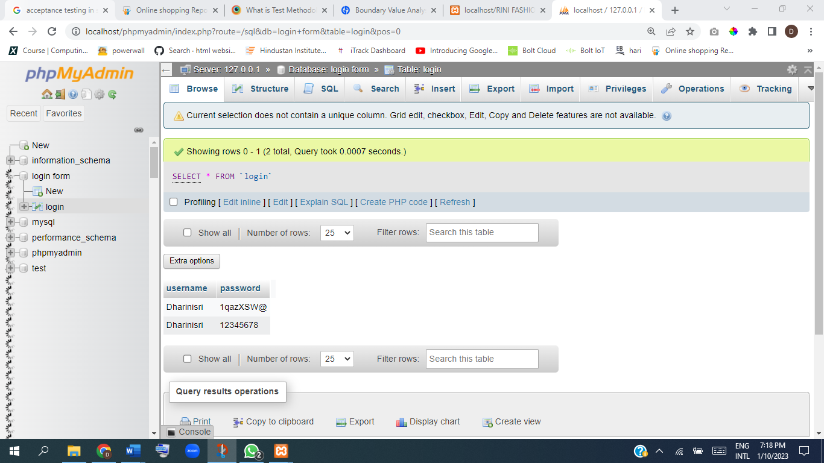

**Fig : 1.8 Save the Data** **base**

